Priyanshu rana 10-11
MS word project

- Good morning everyone.
- My name is Priyanshu rana. I am a class 12 (co. Hindi) student. I live in BIJWASAN, Delhi. My father’s name is Mr. Satay Prakash rana. He is a businessman. My mother’s name is Mrs. Varsha. She is a housewife. I am the only child of my parents. I studied at veer public school and scored 87% in class12th. I am a hardworking boy. One of my best qualities is that I am always ready for a challenge and eager to progress. I love playing sports like football, swimming, and basketball and I’m very passionate about listening to music. I aim to become a businessman like my father. I’m so delighted to be a part of this excellent school. I also hope to learn a lot from my classes and make new friends along the way. Thank you.

Insert tap
Person | Gender | Height in ” ft” | Height in “cm”
Person 1 | Male | 6 | 182.88
Person 2 | Female | 5.8 | 176.784
Person 3 | Male | 5.11 | 155.7528
Person 4 | Male | 6.3 | 192.024



.



- Monday
  - Moring 7am
  - Night 7pm
- Tuesday
  - Moring 7am
  - Night 7pm
- Wednesday
  - Moring 7am
  - Night 7pm
- Thursday
  - Moring 7am
  - Night 7pm
- Friday
  - Moring 7am
  - Night 7pm
- Saturday
  - Moring 7am
  - Night 7pm
- Sunday
  - Moring 7am
  - Night 7pm



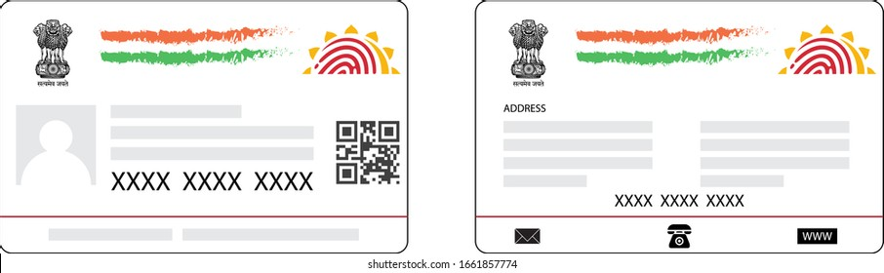
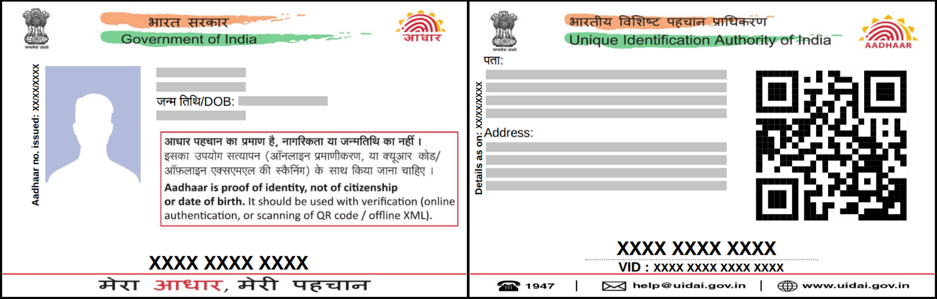
Name: jack
DOB: 11/11/1111
Gende: Billa

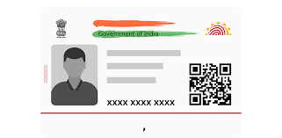

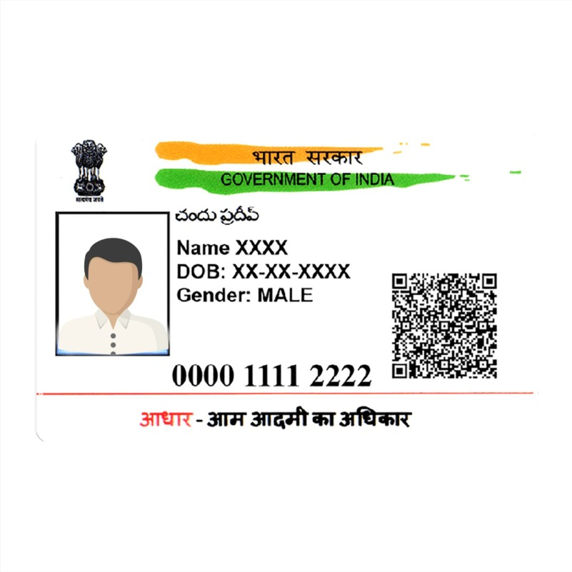



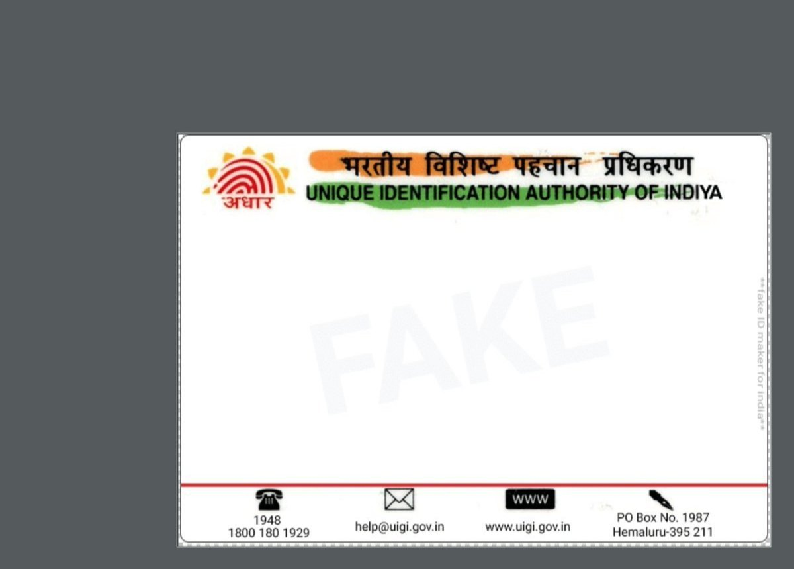

Address:
logo Ke dilo me


